**Some Points to Note**

(Skip, if you don’t care)

* your office laptop comes with 7-zip installed, please use it instead of File Explorer to extract Files, as it is faster.
* Also, note that the antivirus in your office laptop might slow down most file operations like zip file extraction, first time Eclipse startup etc., just be patient

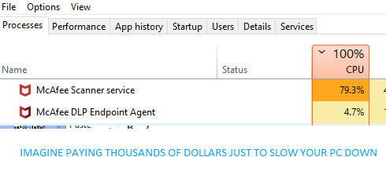

**Initial Setup**

1) Create a new folder on Desktop and name it webdev (or whatever name you want)

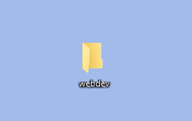

(You will be extracting all the software you download in this folder)

**Eclipse Setup**

(this program is where you will write you java code)

**1) Download Eclipse from below url:**

<https://eclipse.mirror.rafal.ca/technology/epp/downloads/release/2021-12/R/eclipse-jee-2021-12-R-win32-x86_64.zip>

**2)** **Extract it in the webdev folder** **you previously created**

(please google if you don’t know how to extract zip files)

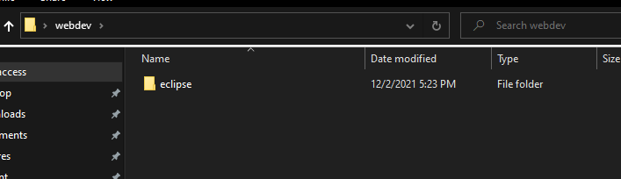

**3) Open eclipse folder and follow below steps**

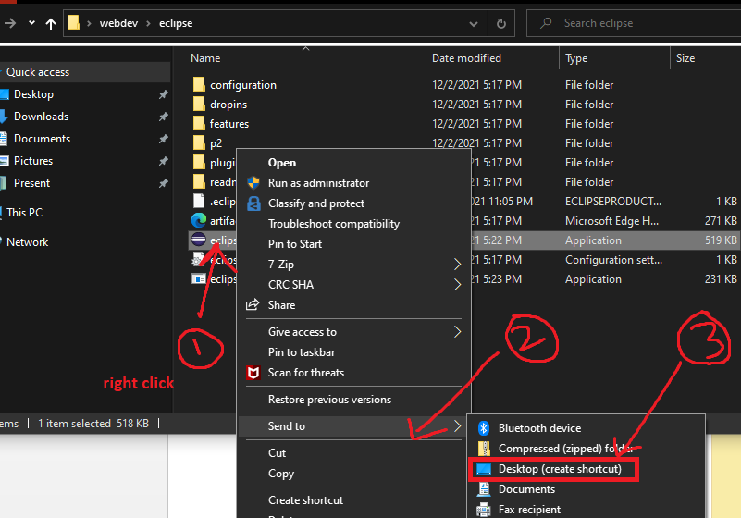

**4) this will create an Eclipse shortcut on Desktop so u can open it later. As shown below**

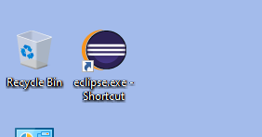

**MySQL Setup**

(we will download mariadb instead, which is similar to mysql for convenience – download size, setup etc.,)

**1) download mariadb from below url:**

<https://dlm.mariadb.com/2150805/MariaDB/mariadb-10.7.3/winx64-packages/mariadb-10.7.3-winx64.zip>

**2) extract it in webdev folder**

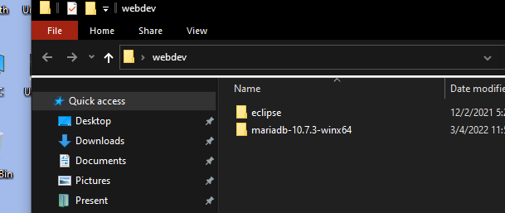

**3) now, open mariadb-10.7.3-winx64 folder > open bin folder > double click mariadb-install-db**

(you only have to run/double click mariadb-install-db once)

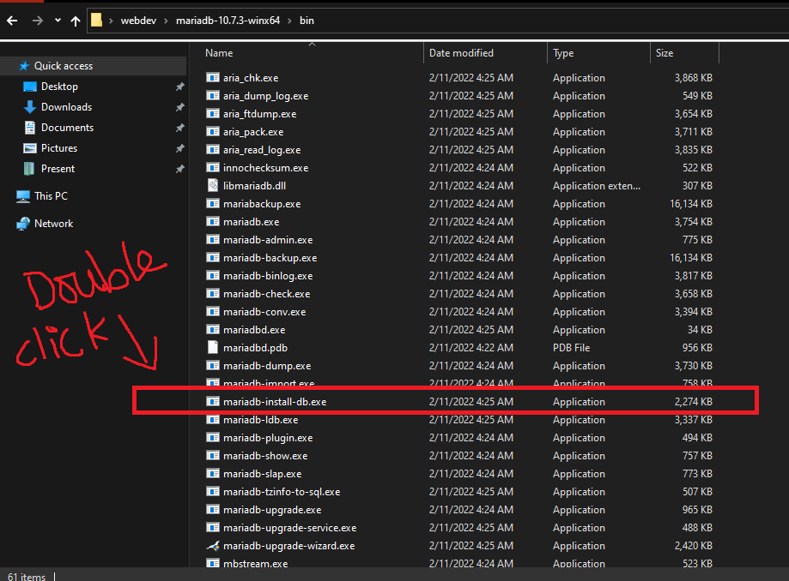

(this will create a data folder in mariadb-10.7.3-winx64 folder as show below, which stores all the databases you create.)

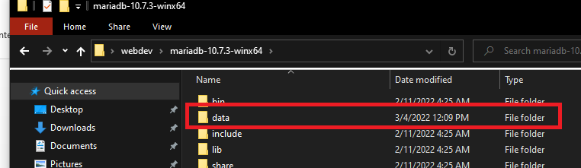

**4) We will not be installing MySQL workbench to run SQL commands as shown in the udemy course (as its not allowed on office laptop), we will type them in MySQL Shell instead. Follow the below steps to open MySQL Shell.**

**Go to webdev folder > mariadb-10.7.3-winx64 folder > bin folder and click on address bar as shown below**

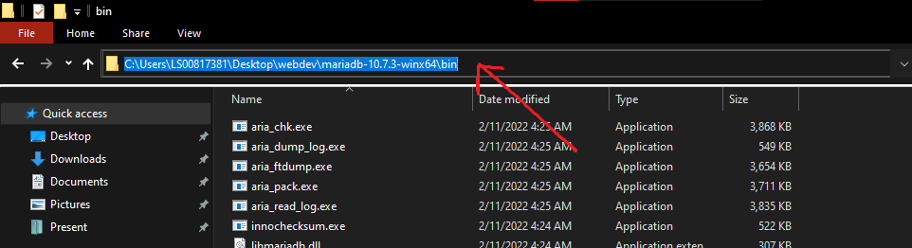

**Type cmd and press enter, you will get a black window (called Console) as shown below**

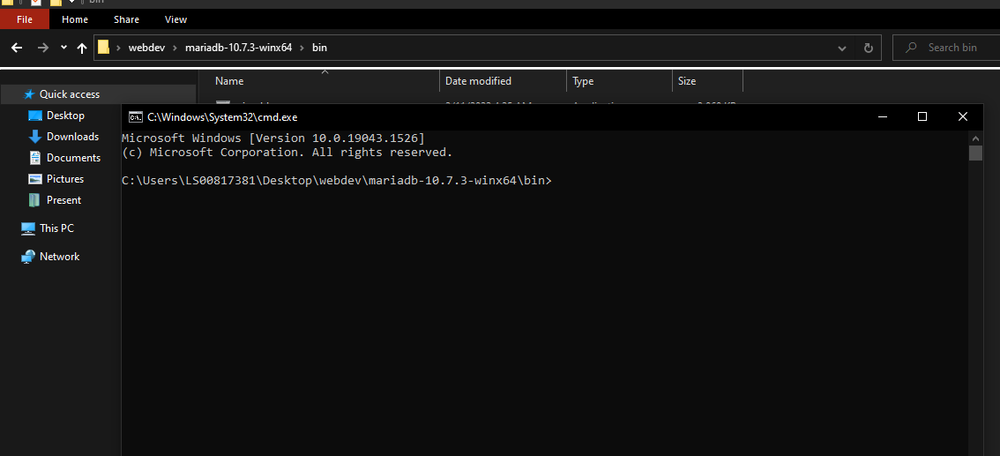

**Type this command: start /b mysqld && mysql -u root and press enter to start MySQL Shell** (you have to run this command every time you are using eclipse!)

(if you get a popup window asking **Allow Access**, just press **Cancel** Button)

**This will open the MySQL shell where you can run SQL Commands. As shown below.**

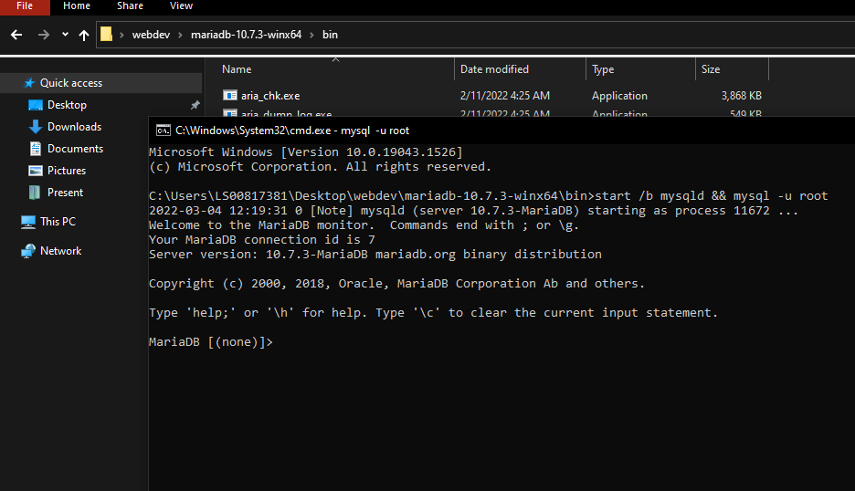

(if you don’t get output as shown above, you can delete data folder and run/double click on mariadb-install-db as shown in previous step which will create the data folder again. And then try starting the MySQL Shell again.)

**Below are some example commands you can run**

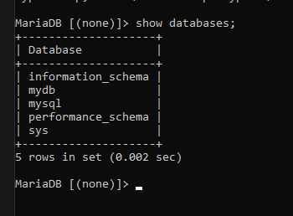

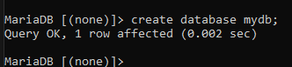

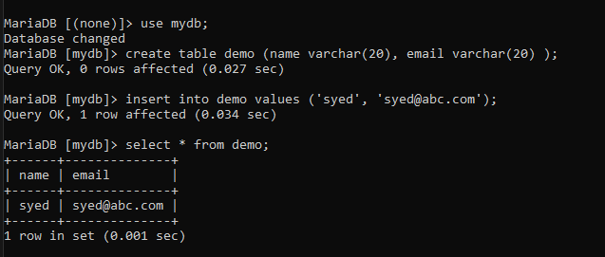

**MySQL Driver**

(this is a .jar file that is used to connect to database form java code, your udemy course instructor will tell you how to use this)

**1)** **since we setup mariadb instead of mysql, we have to use mariadb driver instead of mysql driver.**

**Download mariadb driver from below url:**

<https://dlm.mariadb.com/1936500/Connectors/java/connector-java-3.0.3/mariadb-java-client-3.0.3.jar>

(your udemy instructor will tell you what to do with this file)

**2) now all steps are similar to how its shown in the course, except your types the following code to connect to database**

Class.forName("com.mysql.jdbc.Driver");

conn = DriverManager.getConnection("jdbc:mysql://localhost:3306/mydb", "root", "");

**use this code instead:**

Class.forName("org.mariadb.jdbc.Driver");

conn = DriverManager.getConnection("jdbc:mariadb://localhost:3306/mydb", "root", "");

**notice the differences carefully.**